Week 3

Consumer decision making

Learning objective
- Define the stages in the buyer decision process.
- Understand what marketers should do in each stage.

Decision refers to the resolution reached after consideration. Consumers make several decisions each day; namely, making decisions about the product category, brand, features, where/when/how to buy. Decisions vary with product categories and people involved. Some products require more complex decision making and involve several people in the decision.

Five Stages of the Buyer Decision Process
How consumers make a decision? In general, consumers go through 5 stages. The following table shows how consumers act and how marketers should take actions towards each stages of buyer decision process.

Stage | Consumers’ action | Marketers’ action
Stage 1 Need/Problem recognition | Aware of a difference between the actual and a desired situation. | - Find out potential needs or problems.  - Discover unsatisfied and unfulfilled needs.  - Help consumers identify and recognize the need.
Stage 2 Information search | Gathers information about the attainment of a desired state of affairs. | - Make sure consumers are aware of the brand.  - Provide information about the product and help consumers choose the right product.  - Identify other brands in consumer’s consideration set to plan appropriate competitive appeals.
Stage 3 Alternatives evaluation | Evaluate the alternatives by using the choice criteria. | - Find out how people evaluate brand alternatives and identify which evaluative criteria are important to an individual.  - Educate consumers about attributes and criteria important in evaluating a product.  - Convince how the alternative brands can fulfill the consumers’ choice criteria.
Stage 4  Purchase decision | Narrow down to one choice that intent to purchase.  Decide when, where, how many, and how to purchase. | - Ensure the availability of the products.  - Facilitate the purchase process.
Stage 5  Post-purchase evaluation | Satisfied/Dissatisfied.  Cognitive dissonance. | - Manage/measure satisfaction.  - Maintain quality and offer after-sale service.  - Reduce cognitive dissonance.

- Stage 1: Need/Problem recognition
Every purchase decision made by an individual is started from a problem or need that drives the consumer decision-making process. Problems or needs are the result of differences between a person’s actual and ideal state. To further explain, people live in the perceived reality of present time or actual state. At the same time, people also have desires which reflect how they would like to feel or live in the present time and this is known as an ideal state. When the two states are in balance, the individual does not require anything and no purchase occurs. However, if there is a discrepancy between the two states, a problem or need is created and the consumer decision-making process begins to fulfill this gap.
The discrepancy, or gap, can be created by internal or external drives. Internal drivers are basic human needs such as hunger and security. External drivers happen as people interact with the world and experience something that creates a desire, like seeing a friend driving a new car or hearing about a good new restaurant.
Despite internal or external stimuli, people do not always respond to every gap between the actual and ideal state. Sometimes the gap is not sufficient to drive the person to action. For example, a person may want a new car but does not act on that desire because he or she lacks the financial resources or simply cannot justify the purchase.
It is essential for marketers to learn about the problems and needs of the target market to create value-added products which can fulfill the consumer’s discrepancy. Also, a good knowledge of problem recognition triggers of the target market can lead to an effective marketing strategy, particularly communication.
* Instructor shows videos of products e.g. electric bike, shoe deodorizer, mini IPL, portable scanner, UV sensor bracelet, and Ionic steamer
Students discuss in a group to answer the following questions.
- Think about how to stimulate a “want” for a product. What are problems (pain point) customers currently encounter before a new product is offered? How the new product solve customer’s problems?
- What kind of customers do you want to target?
- What’s the barrier that prevents customers from adopting the product? How can we overcome such barriers?

- Stage 2: Information search
Once a problem is recognized and action is required, people seek information to facilitate the best decision. There are two basic sources of information: internal and external. Internal information search is all information from an individual’s memory, past experiences, research, beliefs and attitudes. Once people have determined that internal information is not sufficient to make the purchase decision, they seek information from outside sources. External information sources include personal associations (family, friends, neighbors), public sources (mass media, experts, government, consumer-rating organizations), commercial sources (advertisement, sales brochures), and experiential sources (product trial and demonstrations).
During the information search, people begin to limit number of alternatives under consideration due to the capacity to gather and process information on many different options. People begin with a very large set of possible alternatives known as the complete set that contains with a variety of options across different brands and products. By gathering information, the consumer learns about competing brands and their features. The unawareness set includes those brands the consumer is unaware of. The awareness set consists of all brands in the product class the consumer is aware of. The awareness set reduces the number of options. As consumers continue the search for information, certain unacceptable options may be eliminated in favor of others and only the consideration set (or evoked set) that contains with the strongest options that meets initial buying criteria to be further evaluated.
Various marketing strategy can be done during this stage. First of all, a firm should make sure that customers aware of and knowledge about the product/brand. Secondly, in order to be able to prepare an effective communication, marketers should find out where customers get and what kind of information they want. If a brand is in consideration set, customers should be provided with product information.

● Stage 3: Alternative evaluation
Once information of products is gathered, consumers require three inputs in order to evaluate the alternatives. To compare and evaluate the products, buyers would create their own criteria based on their age, education, income, cultural values, etc. Then, they determine the importance of each of those criteria that they formed, which they use to decide the members of evoked set. During the process, consumer’s perception toward performance of the alternatives is formed. This means that if a consumer has positive perception and attitude toward the brand, it’s likely that he/she will choose the brand with most favorable option.
The procedure of evaluating alternatives is different, depending on the individual consumer and the specific buying situations. In most cases, consumers decisions made by comparing brand performance on the evaluative criteria (attribute-based choice). In some cases, on the other hand, consumers decisions are based on overall impression, attitudes, emotions associated with the brand (Attitude-based choice). Shortcut or decision heuristics is a quick rules of thumb of using one simple criteria to make purchase decisions.
Marketer tasks are to, firstly, find out how consumers evaluate brand alternatives. Secondly, identify which evaluative criteria are important to an individual customer and educate them that those criteria are fulfilled by the brand.
Note that consumers do not always go through all stages. Sometimes, we purchase a product without planning or what we called impulse buying. There are 3 main levels of decision making. Consumers prone to a routinized/habitual problem-solving behavior when buying low-involvement product, meaning that the cost and risk is low. This behavior include buying product in a quick decision with little search effort; thus, they would have a tendency to buy a familiar brand. Next, customer often engage with limited problem solving when they have some familiarity and experience with product or service, but not with each brands. Therefore, they would put moderate search effort toward the product brand. Customers might switch a brand because of dissatisfaction with earlier brands, discontinuation of brands, or variety seeking. Extended problem-solving is when consumer has little or no prior knowledge of the product class or alternative brands. Plus, buying high-involvement products, meaning high cost and risk, customer would invest more time and effort to search for more information in order to make decision.

● Stage 4: Purchase decision
This stage occurs once the alternatives are narrowed down to one after consumer has evaluated each alternative in the evoked set based on his/her set of criteria. Consumers, then, would decide when, where, and whom to buy from. However, there are some factors that could change purchase decision from original intentions. In other words, consumers might encounter with some situations that could change their decision right before buying. Situational influences are concluded as following:

Situational Factors | Definition | Marketing Tasks
Physical Surroundings | These physical aspects are the most visible part of the purchase situation, which should be present in the right mix to create an admirable atmosphere. The surroundings act as a stimuli for the consumer, and influence him through his five senses, including location, sound, aromas, light, decor, etc. | Need to be present in the right mix to create an atmosphere which is congenial to all consumers
Social Surroundings | Purchase is affected by the presence of other members of the society and their opinion about the purchase and use of products | Marketers should understand the social situation in which a consumer is in order to use the right strategy
Purchase Task | It is the buying intention or motive, meaning why is the purchase being made: whether it’s self-consumption or a gift and what will be the reaction of the person receiving the gift | The task or the purpose and intentions must be known to the marketer in order to make the right communication with right customers
Temporal Factors | This refers to time, whether it is time allotted for shopping, time of the day shopping, time of the season, year, or festivals | Should aware of time customers have an spend on shopping to find ways to accommodate them
Antecedent conditions | These are the availability of resources (money) for buying the product of your choice, the mood, and the attitude | A proper marketing strategy is to designed to get a positive response from the customers, which can be done by identifying the situational factors and the buying process of the consumer

All in all, marketer tasks are to ensure the availability of the products and to facilitate the purchase process for customers. Besides, the human mind uses comparative thinking to make decisions, meaning that they compare options on offer, and compare ourselves to others. Using this concept, marketers could influence buys to make products become more or less attractive in the context of other superior or inferior products. One way to do is to add an inferior product to the list of choices available to the buyer. This can facilitate the choice making process, and customers would perceive that the product is superior and that they made the right choice.

● Stage 5: Post-purchase evaluation
After the purchase, consumers would evaluate the product they bought based on actually product performance and expectation from a product. If the product could perform better than what a customer has expected, he/she would be satisfied by the brand, which they are more likely to repurchase and spread positive word of mouth. In contrast, when the product performs below customer’s expectation, dissatisfaction would occur. Dissatisfaction can truly hurts a firm. Dissatisfied customers may not directly complain to a firm, but they could spread negative word of mouth and never purchase from the brand again.
Post-purchase dissonance could occur after purchase from a brand. Cognitive dissonance is buyer’s remorse/doubt/anxiety over whether they make the right decision, selecting the best choice. In other words, customers might wonder whether they made a right decision buying a particular brand over another or whether it is the right time and right price. This could happen, especially, with high involvement product.
Marketer’s jobs do not end after selling the product. The tasks in this stage are to, firstly, monitor the satisfaction from customer through a survey or social media. Secondly, marketers should manage their performance to meet customer’s needs. Another strategy is to manage customer’s expectation by not over promise. To reduce the dissonance, marketers should ensure customer that they made a right decision, offer a money back guarantee, after purchase personal support, etc.

Discussion Questions
1. Explain the stages of the consumer buyer decision process and describe how you or your family went through this process to make a recent purchase. (AACSB: Communication; Reflective Thinking)
2. Marketers often target consumers before, during, or after a trigger event, an event in one’s life that triggers change. For example, after having a child, new parents have an increased need for baby furniture, clothes, diapers, car seats, and lots of other baby-related goods. Consumers who never paid attention to marketing efforts for certain products may now be focused on ones related to their life change. In a small group, discuss other trigger events that may provide opportunities to target the right buyer at the right time. (AACSB: Communication; Reflective Thinking)

References
Fripp, G. (2017). The Practical Marketing Workbook, 2nd, Sydney, Australia.
Kotler, P. T. and Armstrong, G. (2013). Principles of Marketing, 15th, Pearson.

Appendixes

What Level of Information Search?
The second phase of the consumer decision process is information search. The amount of
information search is dependent upon purchase involvement and various other factors.

For this activity, determine which of the two choices listed would lead the consumer to
extend his/her information search efforts.
Activity
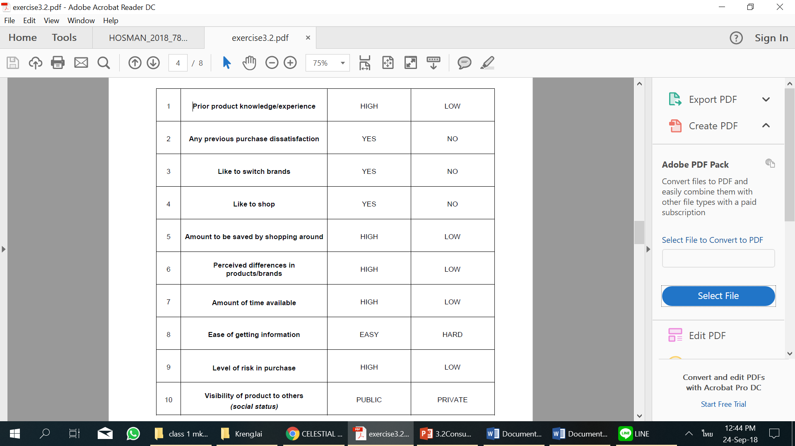

Different Situations, Different Decisions?

Consumers will make different purchase decisions when they are in different situations.
In this activity, you need to match the situation, for choosing a more expensive convenience store over a supermarket, to the consumer’s appropriate situational factor.

Activity/Task
A = Antecedent states: features of the individual person that are not lasting or relatively enduring characteristics (momentary moods/condition)
B = Task definition: reflects the purpose or reason for engaging in the buying or consumption behavior
C = Physical surroundings: the concrete physical and spatial aspects of the environment encompassing a consumer activity
D = Temporal perspective: deal with the effect of time on consumer behavior
E = Social surroundings: deal with other persons present who could have an impact on the individual consumer's behavior; the effects of other people on a consumer in a consumer activity

________1. You’re in a big hurry, and just want a quick shopping experience
________2. You’re feeling a bit tired, just want to get home
________3.You’re just buying a couple of things (like bread/milk)
________4.There’s a convenience store just up the street
________5.It’s 3 in the morning and not many shops are open
________6.You’re not in a good mood don’t want to bump into someone you know
________7.You’re out with the kids and don’t want to take them on ‘big’ shopping trip
________8.You’re driving in a suburb you don’t know and you can see a convenience store on the highway
________9.You just want to grab something to eat in the car
________10.You’re buying some gas and your partner says he/she would like a drink

Understanding In-store Influences
A surprising proportion of purchase decisions are made in-store. Therefore, many retailers
design their premises in a deliberate attempt to influence consumer’s in-store behavior. For
each of the following examples, identify what the firm is trying to achieve by their design.

Activity/Task
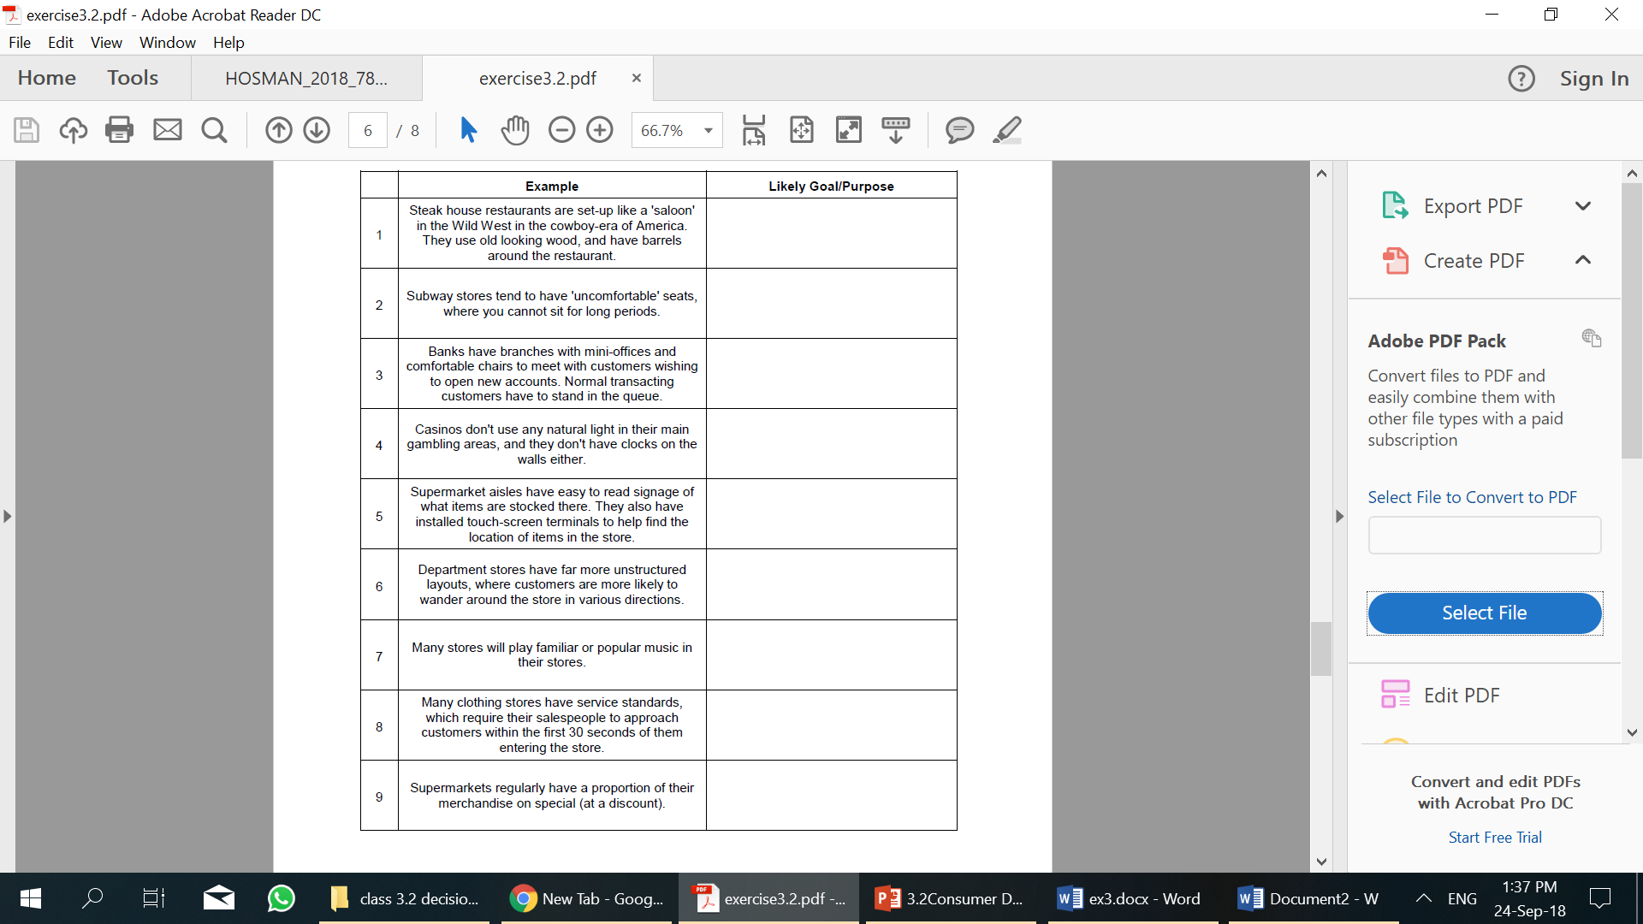

Understanding Consumer Decision-Making Process

Instruction: recall your past purchase of middle to high-priced products, and describe your individual decision-making journey

PRODUCT: _____________________________________________

Need recognition | Information Search | Evaluation | Purchase | Post-purchase | Repurchase
What motivated you to think about the purchase? Who influenced you to consider a product? | What was the Information you sought? What were brands in the consideration set? | What were criteria you used? How did you evaluate a product? | What were decisions you make during the purchase? What were situational factors affecting your purchase moment? | What was your experience with the product? What were your post-purchase behaviors? | How did you make a decision for repurchasing the product category? What made you buy the same brand for the next purchase?
How would a brand trigger a customer’s need for a product? | How can you ensure that a brand be in the consideration set? What would you do so customers are aware and interested in your brand? | How would you increase the evaluating rating or attitudes towards a brand? What a brand should do to make people consider your brand? | What situation factors a brand can improve to influence the purchase moments? | How would you increase customer engagement? What after-sale services/ activities a brand can do to enhance consumer experience | What can a brand do to encourage repurchase build loyalty?

